Week 4
Penetration Testing Report

Introduction

This report document hereby describes the proceedings and results of a Black Box security assessment conducted against the Week 4 Labs. The report hereby lists the findings and corresponding best practice mitigation actions and recommendations.

1. Objective

The objective of the assessment was to uncover vulnerabilities in the Week 4 Labs and provide a final security assessment report comprising vulnerabilities, remediation strategy and recommendation guidelines to help mitigate the identified vulnerabilities and risks during the activity.

2. Scope

This section defines the scope and boundaries of the project.
Application Name | {Open Redirect Labs}, {Exchangeable Image File Format Labs}

3. Summary

Outlined is a Black Box Application Security assessment for the Week 4 Labs.

Total number of Sub-labs: 9 Sub-labs

High | Medium | Low
3 | 2 | 4

High - Number of Sub-labs with hard difficulty level
Medium - Number of Sub-labs with Medium difficulty level
Low - Number of Sub-labs with Easy difficulty level

1. {Open Redirect Labs}

1.1. {A Simple Host!}

Reference | Risk Rating
A Simple Host! | Low
Tools Used
Google Chrome and Burp Suite
Vulnerability Description
I found this vulnerability using the burp suite tool by intercepting it.
How It Was Discovered
Manual Analysis and Automated Analysis
Vulnerable URLs
https://www.bugbountyhunter.org/internship_labs/HTML/open_redirect_lab/lab_1/open_redirect_1.php
Consequences of not Fixing the Issue
An attacker can use this vulnerability to redirect users to other malicious websites, which can lead to phishing or other similar attacks.
Suggested Countermeasures
Maintain a server-side list of all URLs that are permitted for redirection. Instead of passing the target URL as a parameter to a redirector, pass an index into the list.
References
https://cheatsheetseries.owasp.org/cheatsheets/Unvalidated_Redirects_and_Forwards_Cheat_Sheet.html

Proof of Concept

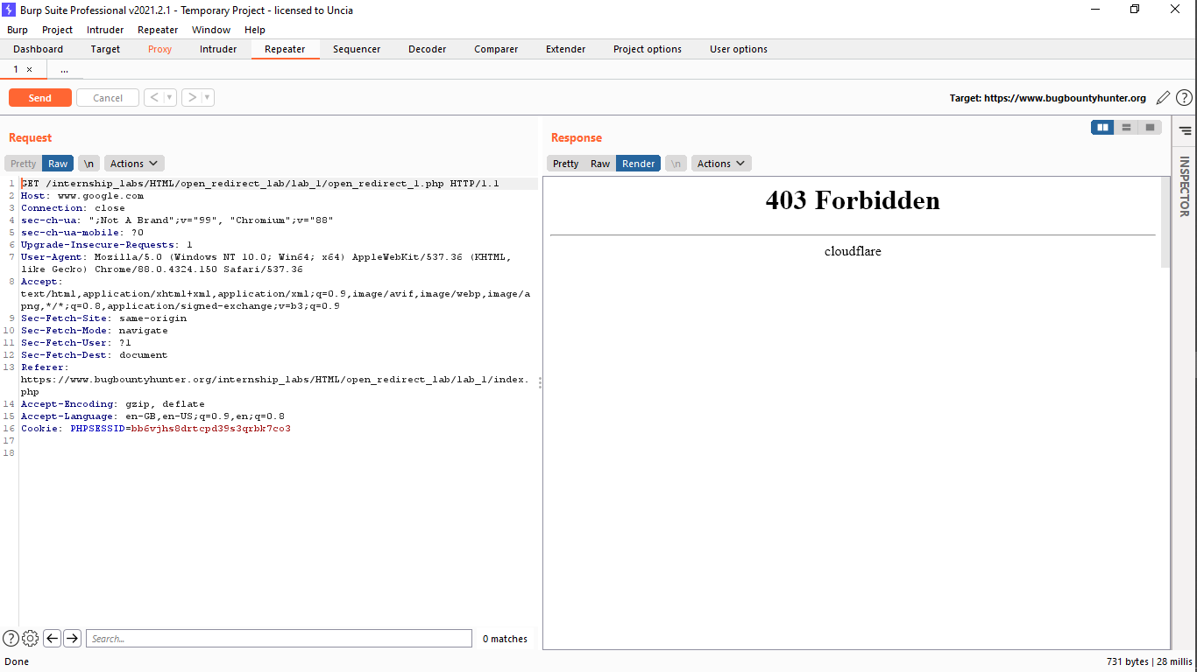

1.2. { Story of a beautiful header!}

Reference | Risk Rating
Story of a beautiful header | Low
Tools Used
Google Chrome and Burp Suite
Vulnerability Description
I found this vulnerability by intercepting a redirect request into burp suite and inserting payload into it and then by forwarding through repeater by verifying the location of the payload result.
How It Was Discovered
Manual Analysis and Automated Analysis
Vulnerable URLs
https://www.bugbountyhunter.org/internship_labs/HTML/open_redirect_lab/lab_2/open_redirect_2.php
Consequences of not Fixing the Issue
An attacker can use this vulnerability to redirect users to other malicious websites, which can lead to phishing or other similar attacks.
Suggested Countermeasures
Remove the redirection function from the application, and replace links to it with direct links to the relevant target URLs.
References
https://cheatsheetseries.owasp.org/cheatsheets/Unvalidated_Redirects_and_Forwards_Cheat_Sheet.html

Proof of Concept

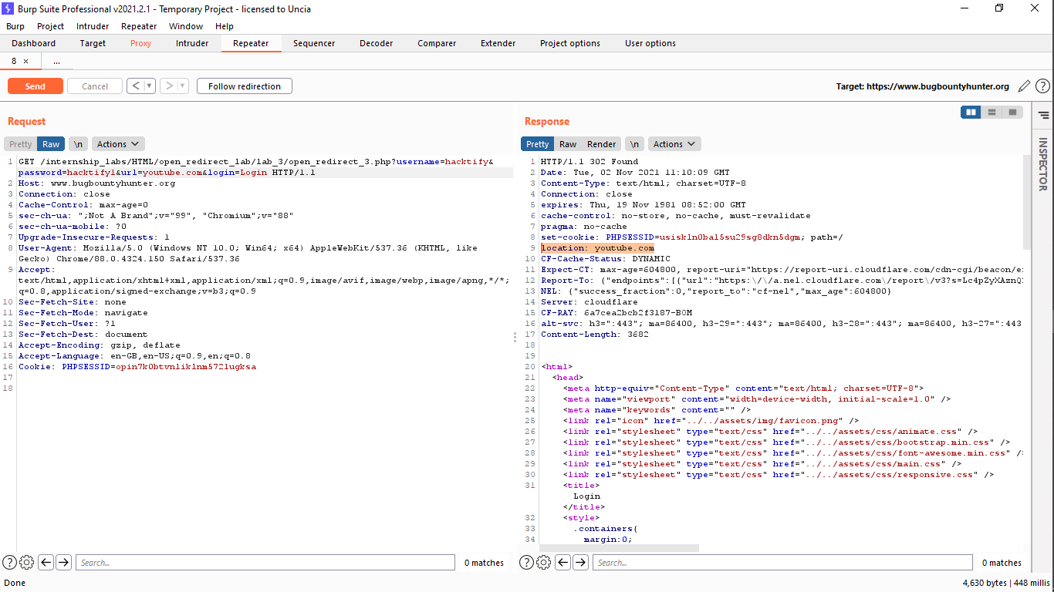

1.3. {Sanitize Params!!}

Reference | Risk Rating
Sanitize params!! | Medium
Tools Used
Google Chrome and Burp Suite
Vulnerability Description
I found this vulnerability by intercepting a redirect request into burp suite and inserting payload into it and then by forwarding through repeater by verifying the location of the payload result.
How It Was Discovered
Manual Analysis and Automated Analysis
Vulnerable URLs
https://www.bugbountyhunter.org/internship_labs/HTML/open_redirect_lab/lab_3/open_redirect_3_dashboard.php
Consequences of not Fixing the Issue
An attacker can use this vulnerability to redirect users to other malicious websites, which can lead to phishing or other similar attacks.
Suggested Countermeasures
The application should use relative URLs in all of its redirects, and the redirection function should strictly validate that the URL received is a valid URL.
References
https://cheatsheetseries.owasp.org/cheatsheets/Unvalidated_Redirects_and_Forwards_Cheat_Sheet.html

Proof of Concept

1.4. {Patterns are important!!}

Reference | Risk Rating
Patterns are important!! | Medium
Tools Used
Google Chrome and Burp Suite
Vulnerability Description
I found this vulnerability by inserting payload at the end of link by adding “?” and then followed by a payload.
How It Was Discovered
Manual Analysis and Automated Analysis
Vulnerable URLs
https://www.bugbountyhunter.org/internship_labs/HTML/open_redirect_lab/lab_4/open_redirect_4.php///youtube.com
Consequences of not Fixing the Issue
An attacker can use this vulnerability to redirect users to other malicious websites, which can lead to phishing or other similar attacks.
Suggested Countermeasures
Maintain a server-side list of all URLs that are permitted for redirection. Instead of passing the target URL as a parameter to a redirector, pass an index into the list.
References
https://cheatsheetseries.owasp.org/cheatsheets/Unvalidated_Redirects_and_Forwards_Cheat_Sheet.html

Proof of Concept

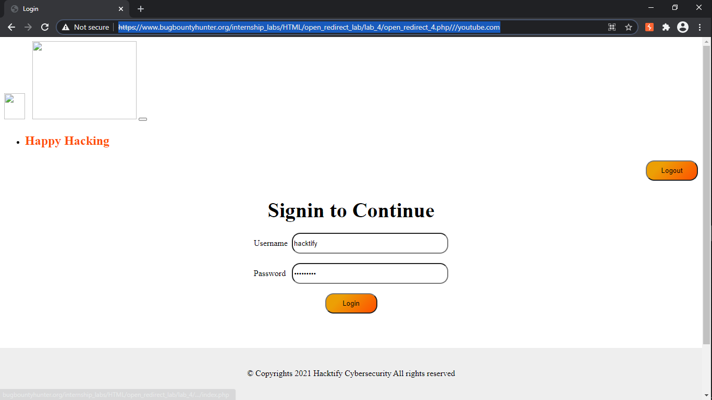

1.5. {File Upload? Redirect IT!}

Reference | Risk Rating
File upload? Redirect IT! | Low
Tools Used
Google Chrome and Burp Suite
Vulnerability Description
I found this vulnerability by intercepting a file upload request into burp suite and changing file name to make it vulnerable.
How It Was Discovered
Manual Analysis and Automated Analysis
Vulnerable URLs
https://virtuallytesting.com/
Consequences of not Fixing the Issue
An attacker can use this vulnerability to redirect users to other malicious websites, which can lead to phishing or other similar attacks.
Suggested Countermeasures
Maintain a server-side list of all URLs that are permitted for redirection. Instead of passing the target URL as a parameter to a redirector, pass an index into the list.
References
https://cheatsheetseries.owasp.org/cheatsheets/Unvalidated_Redirects_and_Forwards_Cheat_Sheet.html

Proof of Concept

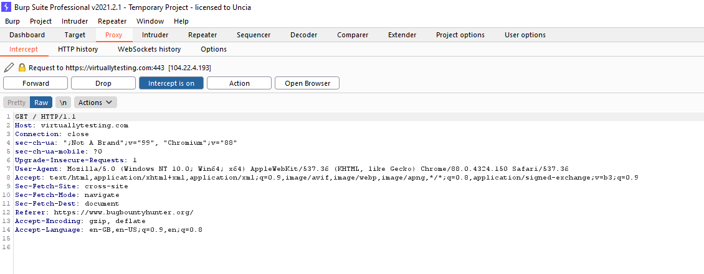

1.6. {Same Param Twice!}

Reference | Risk Rating
Same Param Twice! | High
Tools Used
Google Chrome and Burp Suite
Vulnerability Description
I found this vulnerability by intercepting a redirect request into burp suite and inserting payload into it and then by forwarding through repeater by verifying the location of the payload result.
How It Was Discovered
Manual Analysis and Automated Analysis
Vulnerable URLs
https://www.bugbountyhunter.org/internship_labs/HTML/open_redirect_lab/lab_6/open_redirect_6_dashboard.php
Consequences of not Fixing the Issue
An attacker can use this vulnerability to redirect users to other malicious websites, which can lead to phishing or other similar attacks.
Suggested Countermeasures
Remove the redirection function from the application, and replace links to it with direct links to the relevant target URLs.
References
https://cheatsheetseries.owasp.org/cheatsheets/Unvalidated_Redirects_and_Forwards_Cheat_Sheet.html

Proof of Concept

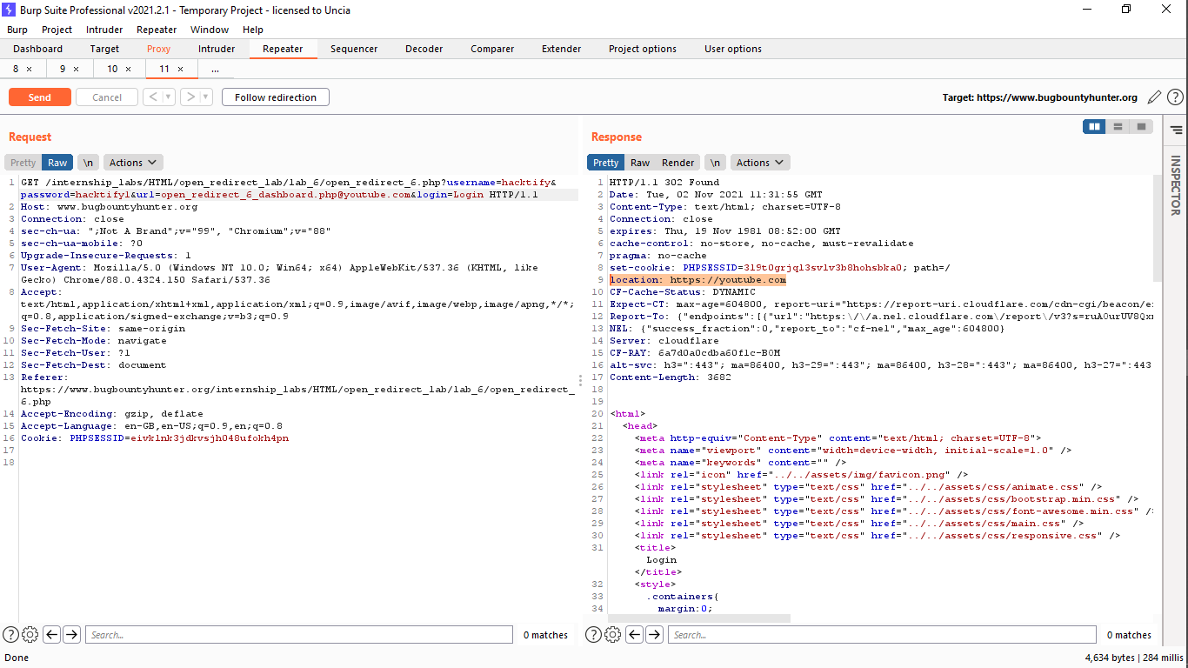

1.7. {Domains? Not Always!}

Reference | Risk Rating
Domains? Not Always! | High
Tools Used
Google Chrome and Burp Suite
Vulnerability Description
I found this vulnerability by intercepting a redirect request into burp suite and inserting payload into it and then by forwarding through repeater by verifying the location of the payload result.
How It Was Discovered
Manual Analysis and Automated Analysis
Vulnerable URLs
https://www.bugbountyhunter.org/internship_labs/HTML/open_redirect_lab/lab_7/open_redirect_7_dashboard.php&url=google.co,m&login=Login
Consequences of not Fixing the Issue
An attacker can use this vulnerability to redirect users to other malicious websites, which can lead to phishing or other similar attacks.
Suggested Countermeasures
Maintain a server-side list of all URLs that are permitted for redirection. Instead of passing the target URL as a parameter to a redirector, pass an index into the list.
References
https://cheatsheetseries.owasp.org/cheatsheets/Unvalidated_Redirects_and_Forwards_Cheat_Sheet.html

Proof of Concept

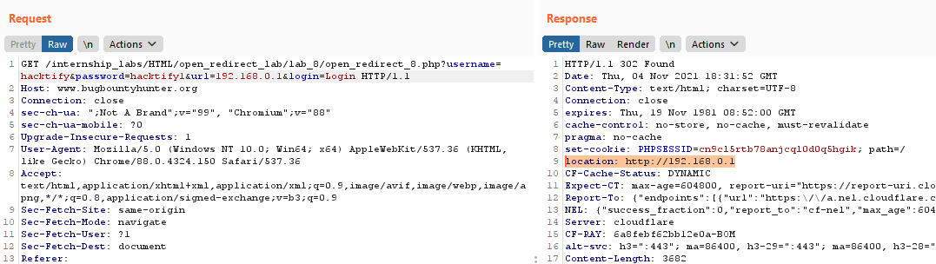

1.8. {Style digit symbols < 3}

Reference | Risk Rating
Style digit symbols < 3 | High
Tools Used
Google Chrome and Burp Suite
Vulnerability Description
I found this vulnerability by intercepting a redirect request into burp suite and inserting IP Address as payload into it and then by forwarding through repeater by verifying the location of the payload result.
How It Was Discovered
Manual Analysis and Automated Analysis
Vulnerable URLs
https://www.bugbountyhunter.org/internship_labs/HTML/open_redirect_lab/lab_8/open_redirect_8.php
https://www.google.com/?gws_rd=ssl
Consequences of not Fixing the Issue
An attacker can use this vulnerability to redirect users to other malicious websites, which can lead to phishing or other similar attacks.
Suggested Countermeasures
Remove the redirection function from the application, and replace links to it with direct links to the relevant target URLs.
References
https://cheatsheetseries.owasp.org/cheatsheets/Unvalidated_Redirects_and_Forwards_Cheat_Sheet.html

Proof of Concept

2. {Exchangeable Image File Format Labs}

2.1. Lets PII!

Reference | Risk Rating
Lets PII! | Low
Tools Used
Google Chrome
Vulnerability Description
I found this vulnerability by uploading an image into the profile photo section. I found the entry point for EXIF in the profile photo upload section. This allowed me to upload images containing sensitive data.
How It Was Discovered
Manual Analysis
Vulnerable URLs
https://www.bugbountyhunter.org/internship_labs/HTML/exif_lab/lab_1/exif.php
Consequences of not Fixing the Issue
This vulnerability violates the privacy of a user and shares sensitive information of the user who uploaded an image on the vulnerable websites.
Suggested Countermeasures
Disable geotagging on the digital device you use to take photographs.
References
https://photographylife.com/what-is-exif-data

Proof of Concept

